R V College of Engineering
INTERNALS OF CPYTHON

WORKSHOP REPORT

Event Name
In-depth Workshop on CPython Internals by Prashanth Raghu
at RVCE, 2025

Organized by
The Coding Club Of RVCE

Date of Event: Saturday, 8th March
Venue: ISE Seminar Hall, RV College of Engineering
Date of Report Submission: 11th March, 2025
Faculty Coordinator: Dr.Sagar B M, Dean Student Affairs
Dr. Padmashree T, Prof. Rekha BS
Coordinators: Harsh Gupta (1RV22IS020)
Muhammad Umar Yaksambi (1RV23CD031)
Rahul Patnaik (1RV23CD041)
Aditiya Raj (1RV23CY001)
Varenya T (1RV23BIS041)

Brief Overview of the Event
The Coding Club of RVCE hosted an immersive workshop that delved into the intricate internals of CPython. With the goal of bridging theoretical knowledge with practical insights, the event offered a comprehensive exploration of Python’s source code—unveiling the journey from code parsing to execution. The session was tailored to spark curiosity and foster a deep understanding of the underlying mechanisms that power Python.

Purpose and Objectives
The workshop was designed with the following key objectives in mind:
- Deep-Dive Technical Exploration:
Provide a granular look into the CPython architecture, explaining the flow from source code parsing to bytecode compilation and eventual interpretation.
- Understanding Memory Management:
Analyse Python’s strategies for memory allocation, garbage collection, and object management, thereby clarifying how Python optimizes resource utilization.
- Source Code Level Insights:
Offer a detailed walkthrough of the CPython source code, including discussions on the parser, compiler, assembler, and interpreter phases.
- Fostering Open-Source Engagement:
Inspire participants to contribute to Python’s open-source community by demystifying the complexities of its internal workings and highlighting best practices for code contributions.
- Enhancing Problem-Solving Skills:
Encourage analytical thinking through live demonstrations and interactive Q&A sessions, enabling participants to link theoretical concepts with practical applications.

Target Audience
The workshop was primarily aimed at computer science students and engineering professionals. However, its accessible design welcomed anyone with a keen interest in programming—ranging from beginners eager to learn the fundamentals to experienced coders looking to deepen their understanding of Python’s internals. The session was especially beneficial for those interested in system-level programming and open-source contributions.

Detailed Event Description

Opening Session
The event commenced with a brief introduction by the Coding Club’s leadership, outlining the agenda and emphasizing the significance of understanding Python’s inner workings. The stage was set for an in-depth technical exploration, capturing the enthusiasm of a diverse audience.

Speaker Presentations
Prashanth Raghu:
Profile: Author of Internals of Python 3.x and Source code exploration with Memcached, and a veteran contributor to the Python open-source community with 17 years of experience.
Founder of Gonagoor Technological solution.
Key Segments:
Python Lifecycle: Detailed examination of the progression from parsing and compiling to assembling and interpreting code.
Memory Management Insights: An explanation of how Python handles memory allocation, reference counting, and garbage collection.
Python Object Internals: A focused discussion on the underlying design of built-in data types such as lists, tuples, and dictionaries.
Comparative Analysis: Offered insights into compiler design, highlighting similarities and differences between Python’s architecture and other compiler models. These sessions provided a rare behind-the-scenes look at the operational mechanics of Python.

Chirag S Rao:
Profile: Head of Growth at Gonagoor Technological Solutions
Key Segments:
Open-Source Contributions: Encouraged participants to actively engage with and contribute to Python’s evolving codebase.
Real-World Applications: Illustrated how a deep understanding of system internals can drive innovation and efficient problem-solving in software development.
Inspiration for Open Source: Motivated attendees to explore and leverage open-source technologies to enhance their professional skills and career prospects.
Interactive Segments

Outcomes and Key Takeaways
- Enhanced Technical Acumen:
Participants left with a thorough understanding of Python’s architecture, particularly the nuances of its parser, compiler, interpreter, and memory management systems.
- Practical Exposure:
The live demonstrations and hands-on exercises enabled attendees to witness the practical implications of theoretical concepts, thereby solidifying their learning experience.
- Motivation for Open Source:
Insights into the inner workings of CPython, coupled with guidance on contributing to open-source projects, spurred many attendees to explore opportunities in collaborative development.
- Bridging Theory and Practice:
The workshop successfully connected abstract programming concepts with tangible examples from real-world Python implementations, emphasizing the value of practical application in technical education.
- Community Building:
The interactive nature of the event fostered a sense of community among attendees, encouraging future collaborations and knowledge-sharing initiatives.

Concluding Remarks
The Workshop on CPython Internals was a landmark event that effectively demystified the complexities of Python’s core architecture. Through detailed presentations, live coding demonstrations, and active participant engagement, the session not only enriched technical understanding but also ignited a passion for open-source innovation. The Coding Club of RVCE has set a high standard for future events, promising even more comprehensive and engaging technical sessions in the upcoming semesters.
The success of this workshop reinforces the importance of continuous learning and collaborative exploration in the rapidly evolving field of technology, ultimately contributing to the professional growth of every participant.
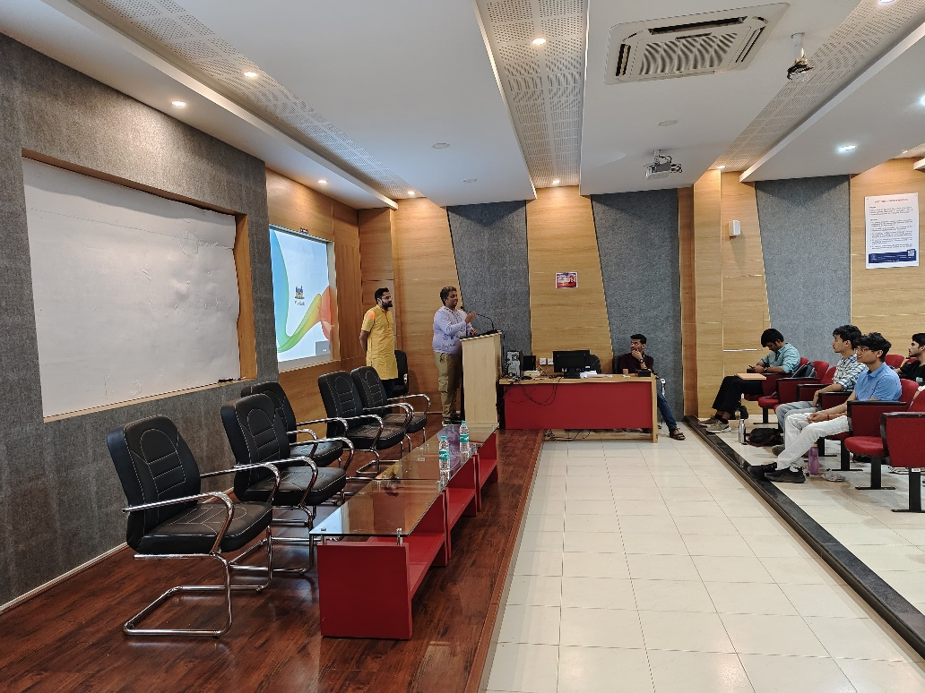
Prashant Raghu during the Q&A Session

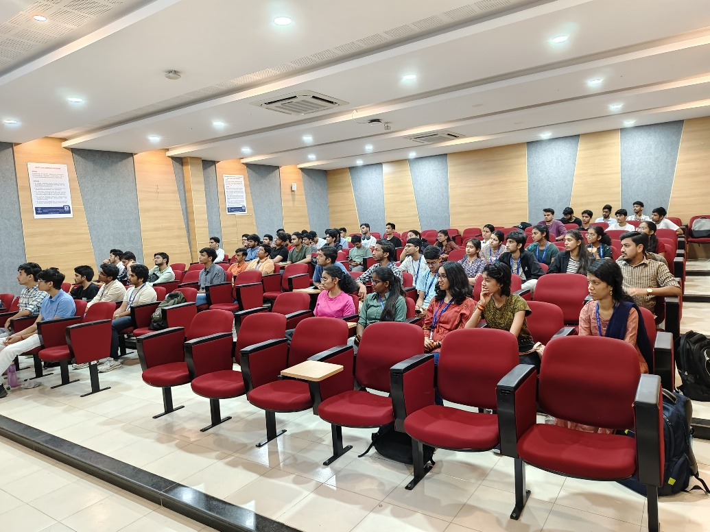

Participants of the workshop during the session
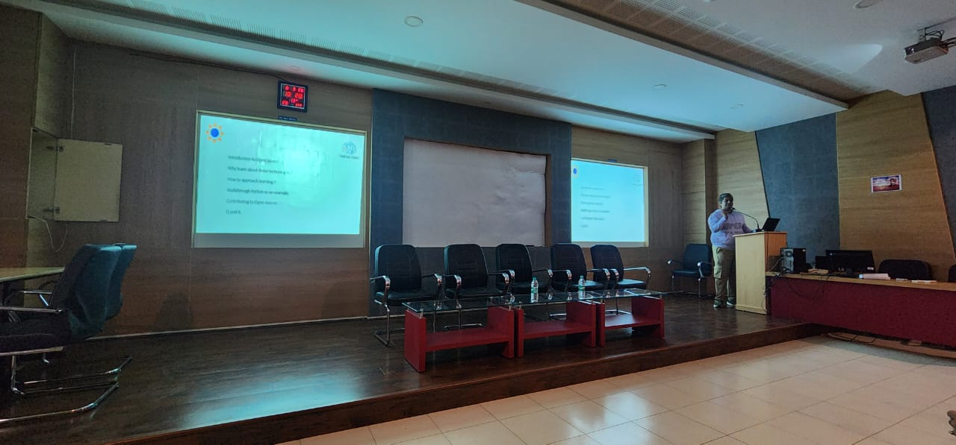

Prashant Raghu explaining how Python handles memory allocation

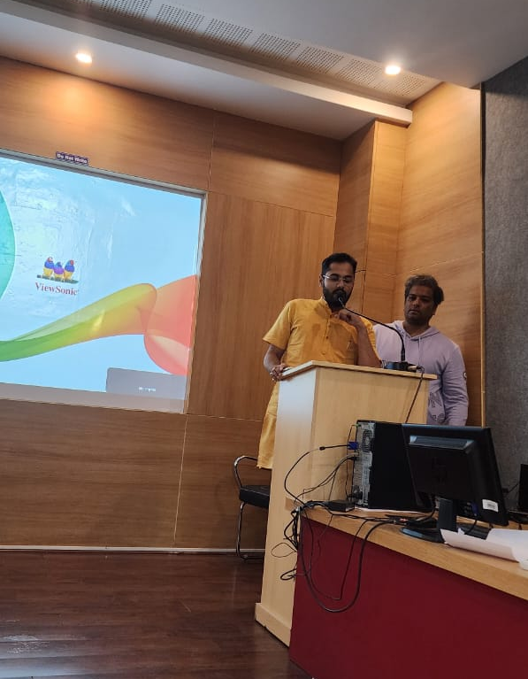
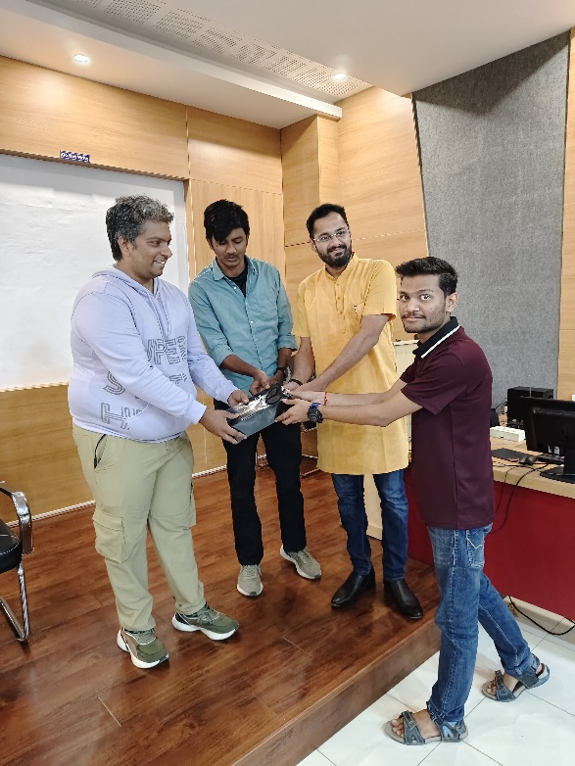

Chirag S Rao emphasizing the President of The Coding Club,
Importance of Open-Source Harsh Gupta presenting the token
of appreciation
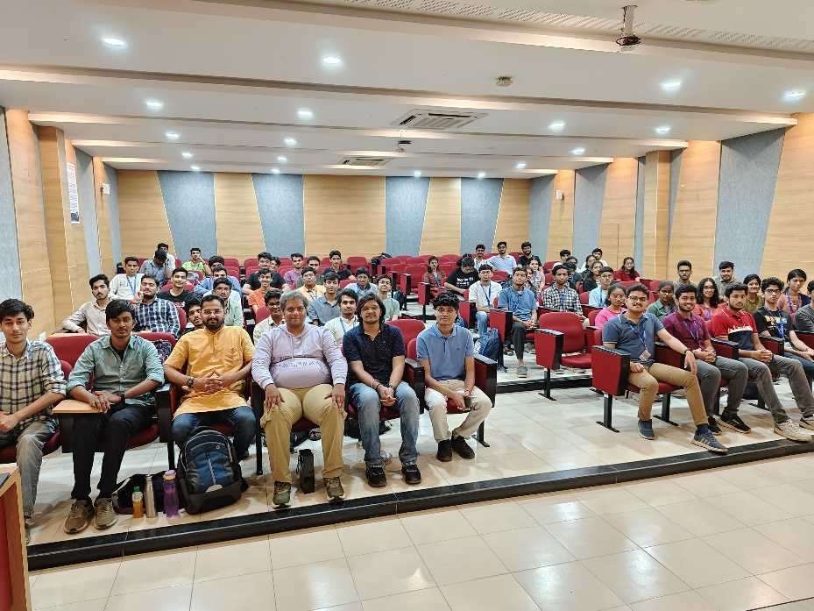
Speaker Prashant Ragu, Chirag Rao and The Coding Club team with the participants

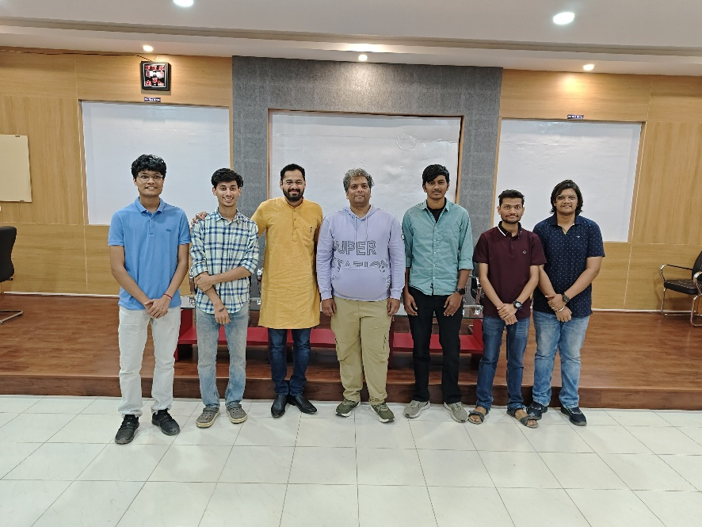

The Speakers Prashant Raghu, Chirag Rao with
the Coding Club Coordinating team

